j0293098 101C North Greenville Ave

## G

# C

### Of Dallas

**International Stroke Conference 2023**

**February 8-10, 2023**

**Kay Bailey Hutchison Convention Center**

**Dallas, Texas**

### Creative Greenery

#440, Allen, TX 75002

Tel: 972-442-5592 Fax: 866-931-2437

Email: [Todd@dallasgreenery.com](mailto:Todd@dallasgreenery.com" \t "_parent)

 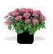   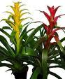

Mums Kalanchoes Bromeliads

**FLOWERING PLANTS**

|  |  |  |  |  |
| --- | --- | --- | --- | --- |
| DESCRIBE | COLOR | PRE-PAID PRICE | CONVENTION PRICES | AMOUNT |
| MUMS | Yellow\_\_\_ White\_\_\_ Lavender\_\_\_ | $25.00 | $28.00 |  |
| KALANCHOES | Yellow\_\_\_ Pink\_\_\_ Red\_\_\_ | $25.00 | $28.00 |  |
| BROMELIAD | Red\_\_\_ Pink\_\_\_ Orange\_\_\_ | $35.00 | $40.00 |  |

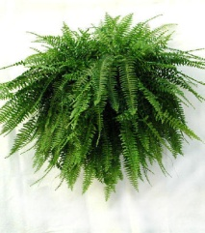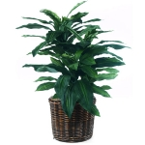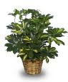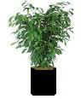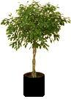

Small Fern Large Fern Dracaena Arborcolla 2-4’ Ficus 6’ Ficus Palm

**GREEN PLANTS**

|  |  |  |  |  |  |
| --- | --- | --- | --- | --- | --- |
| HEIGHT | TYPE | SPECIFY | PRE-PAID PRICE | CONVENTION PRICE | AMOUNT |
| SMALL | Ferns |  | $28.00 | $32.00 |  |
| LARGE | Ferns |  | $38.00 | $42.00 |  |
| 2-3’ | Palm, Arborcolla, Spath, Ficus | Circle Preference | $42.00 | $46.00 |  |
| 4’ | Palm, Ficus, Dracaena | Circle Preference | $52.00 | $56.00 |  |
| 5’ | Palm, Ficus | Circle Preference | $62.00 | $66.00 |  |
| 6’ | Palm, Ficus | Circle Preference | $72.00 | $76.00 |  |
| 8’ | Palm, Ficus | Circle Preference | $82.00 | $86.00 |  |

**CONTAINER SELECTION**

|  |  |  |
| --- | --- | --- |
| DESCRIPTION | SPECIFY | PRICE |
| White\_\_\_\_\_\_ Black\_\_\_\_\_\_ Wicker Baskets\_\_\_\_\_\_ | Circle Preference | Free |
| Glass Bubble Bowl |  | $24.00 |

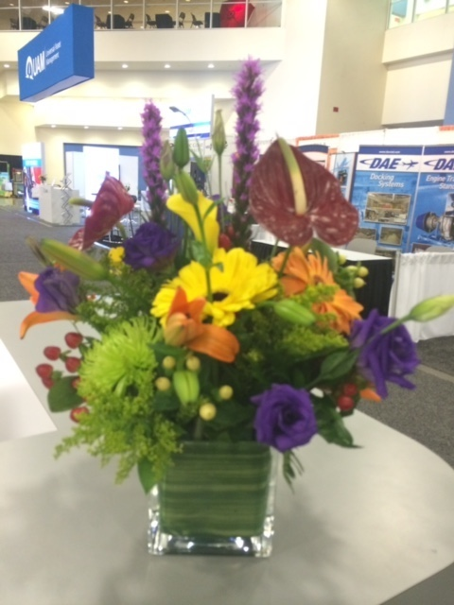 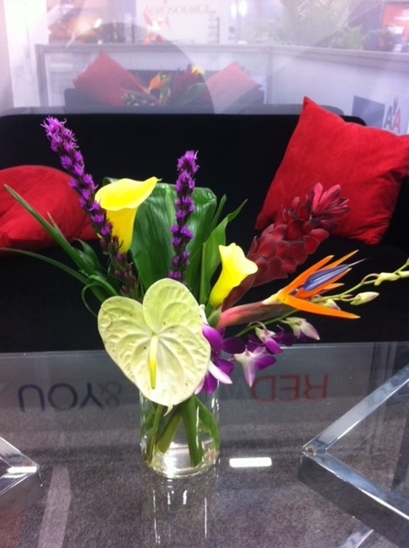

Spring Tropical

**FRESH FLORAL ARRANGEMENTS**

|  |  |  |  |  |
| --- | --- | --- | --- | --- |
| DESCRIPTION | SPECIFY | PRE-PAID PRICE | CONVENTION PRICE | AMOUNT |
| Spring Floral Arrangements | Circle One: Round or One-Sided | $70.00 | $80.00 |  |
| Exotic Tropical Floral Arrangements |  | $80.00 | $90.00 |  |

**PAYMENT INFORMATION**

|  |
| --- |
| Sub Total:\_\_\_\_\_\_\_\_\_\_\_\_\_\_\_ Sales Tax (8.25%):\_\_\_\_\_\_\_\_\_\_\_\_\_\_ Event Total:\_\_\_\_\_\_\_\_\_\_\_\_\_\_  Payment Enclosed: Check:\_\_\_\_ Visa\_\_\_\_ M/C\_\_\_\_ AMX\_\_\_\_  Credit Card No:\_\_\_\_\_\_\_\_\_\_\_\_\_\_\_\_\_\_\_\_\_\_\_\_\_\_\_\_\_\_\_\_\_\_\_\_\_\_\_\_\_\_ Exp Date:\_\_\_\_\_\_\_\_\_\_\_\_\_\_ CID\_\_\_\_\_\_\_\_\_\_\_  Card Holder Name:\_\_\_\_\_\_\_\_\_\_\_\_\_\_\_\_\_\_\_\_\_\_\_\_\_\_\_\_\_\_\_\_\_\_\_\_\_\_\_\_\_\_\_\_\_\_\_\_\_\_\_\_\_\_\_\_\_\_\_\_\_\_  Signature:\_\_\_\_\_\_\_\_\_\_\_\_\_\_\_\_\_\_\_\_\_\_\_\_\_\_\_\_\_\_\_\_\_\_\_\_\_\_\_\_\_\_\_\_\_\_\_\_\_\_\_\_\_\_\_\_\_\_\_\_\_\_\_\_\_\_\_\_\_\_ |

**COMPANY INFORMATION**

|  |
| --- |
| Booth #\_\_\_\_\_\_\_\_\_\_\_  Company:\_\_\_\_\_\_\_\_\_\_\_\_\_\_\_\_\_\_\_\_\_\_\_\_\_\_\_\_\_\_ E-Mail:\_\_\_\_\_\_\_\_\_\_\_\_\_\_\_\_\_\_\_\_\_\_\_\_\_\_\_\_\_\_\_\_\_\_  Phone:\_\_\_\_\_\_\_\_\_\_\_\_\_\_\_\_\_\_\_\_\_\_\_\_\_\_\_\_\_\_\_\_\_ Fax:\_\_\_\_\_\_\_\_\_\_\_\_\_\_\_\_\_\_\_\_\_\_\_\_\_\_\_\_\_\_\_\_\_\_\_\_  Address:\_\_\_\_\_\_\_\_\_\_\_\_\_\_\_\_\_\_\_\_\_\_\_\_\_\_\_\_\_\_\_\_\_\_\_\_\_\_\_\_\_\_\_\_ City:\_\_\_\_\_\_\_\_\_\_\_\_\_\_\_\_\_\_\_\_\_\_\_\_\_\_\_\_\_\_\_\_\_\_\_\_  State:\_\_\_\_\_\_\_\_\_\_\_\_\_\_\_\_\_ Zip:\_\_\_\_\_\_\_\_\_\_\_\_\_ Booth Representative:\_\_\_\_\_\_\_\_\_\_\_\_\_\_\_\_\_\_\_\_\_\_\_\_\_\_\_\_\_\_ |